OGF Information System

Problem Description
Universities and research institutes are real organizations that have computing centres. Each organization is autonomous and has their own, security infrastructure, policies, systems etc. and are ultimately responsible for their resources.
Scientists from different institutions collaborate on specific research topics and they would like to use the resources available to them. The difficulty faced by the collaboration is that each organization where the resources are located have different, security infrastructures, policies, systems etc.
To solve this problem the security infrastructures, policies, systems need to be generalized. A common security model is adopted where usage of resources at an organization is dependent on the collaboration to which the user is participating. Types of systems are also generalized so that the user does not have to understand the details of different implementations that organizations have. An interface is required at the organizational boundary that maps the generalized system to the organizational specific security model and the local system.
Users and higher level services need to acquire information of the resources available in the grid in order to make decisions on how to use them.

Experience from GIN Working Group
Over recent years a number of multi-institutional grid projects, many of which had a strong regional presence, have emerged to help coordinate institutions and enable e-science collaboration. Today, we face a situation where a number of multi-institutional grid projects exist, most of which have slightly different middleware. The Grid Interoperability Now Community Group (GIN-CG) is an OGF activity which focuses on interoperation between multi-institutional e-Science infrastructures. The goal is to understand what can be done on the short term to enable interoperation between the existing e-Science infrastructures. It was envisaged that this work would identify the areas where future standardisation would be required for sustainability. The interoperability was broken down into 4 core areas, jobs, data, authentication and information with the gin-info activity focusing on interoperation between existing information systems.
This activity developed various adaptors, translators and plug-ins to enable different grid information systems to interoperate. The results of this activity were demonstrated at Super Computing 2006. This demonstration activity highlighted the difference between content and delivery of information. While it is possible to work around problems of the delivery mechanisms, it is not possible to work around problems with the content. There must be agreement between the structure and semantics of the information. Non-exiting information or information with alternative semantics can not be translated. It is for this reason that the group identified the need for the minimal information which is required to meet an intra grid use case.
The glue-wg was initiated to describe a common schema which meets the requirements for the intra-grid uses cases. Any work on information content, structure and semantics should be done in this group.
While it is possible to work around the different delivery mechanisms, some standards in this area would go a long way to help the interoperation efforts.
Existing Systems
The following is a brief overview of the architectures of the information systems from infrastructures which participated in the gin-info activity.
OSG, NGS and APAC
The Open Science Grid, UKs National Grid and Australian Partnership for Advanced Computing all use the Meta-data Directory Service version 2 from the Globus project. The data model used in MDS is LDAP and the information that can be used in the system is defined by an LDAP schema. The information system is made of three parts; information providers, Grid Resource Information Services (GRIS) and Grid Information Index Services (GIIS). An information provider is a script that obtains information about the local resource. This information is sent to standard out in the LDIF notation. The GRIS is deployed on the same node as the information provider. The GRIS can be queried via an ldapsearch with a base dn of mds-vo-name=local,o=grid. When the GRIS is queried, it will execute the information provider, obtain the LDIF and return the result of the query. The GRIS can register itself with a GIIS. The GIIS can be then queried via an ldapsearch with a base dn set to the GIIS name. In this case, the back end will query all GRISes that have registered to the GIIS. A GIIS can register itself with another GIIS. All information can be found from one point by building up a hierarchal GIIS structure. To make the system more efficient, a caching mechanism is built into the GIIS and GRIS. This makes the system more efficient but will also result in the information being slightly stale
The standard deployment model for MDS is a GRIS deployed on the resource, a site GIIS is a site boundary and a top level GIIS
GIIS
top-level
GIIS
site-level
GRIS
GRIS
provider
provider
Site

EGEE
The project preceding EGEE initially deployed MDS 2. However, there were a number of critical problems found with the system which stopped it from functioning. If there were any problems in the lower levels of the hierarchy, due to the levels in the information system hierarchy not being completely decoupled, problems in the lower levels would also affect the higher levels. A test was conducted to compare to top-level MDS with the performance of a standard OpenLDAP database. Each site GIIS was queried and the returned LDIF inserted into the OpenLDAP database. As the standard OpenLDAP database proved successful in the tests, it was decided that it should be used to replace the top level GIIS. This was named the Berkley Database Information Index (BDII). Periodically, the BDII would query each site GIIS and use the returned LDIF to populate the OpenLDAP database. As the size of the EGEE increased, problems were also seen with the site GIIS and GRIS. These were eventually also replaced with OpenLDAP databases, named site-level BDII and resource-level BDII respectively.
BDII
top-level
BDII
site-level
BDII
resource
BDII
resource
provider
provider
Site
Nordugrid
Nordugrid also found problems with the initial deployment of MDS2. When multiple clients request information, GIIS-es become seriously overloaded due to serving multiple recursive LDAP searches. Further internal queries for updating the cache cause timeouts and stability problems. However, Nordugrid solved the problem in different ways. It uses a top level GIIS only to index the actual GRIS which are then queried in parallel by the brokering client, hence no caching is involved.
GIIS
GRIS
provider
Site
Naregi
The NAREGI information service is a built around the concept of a cell domain. At the core of the cell domain is a relational database. An OGSA-DAI interface is used to query the information and an Aggregator Service is used to populate the database. The Aggregator Service obtains information from either querying CIMOMs or other cell domains.
RDB
Light-
weight
CIMOM
Service
Aggregator
Service
OS
Processor
File System
CIM Providers
●
●
RUS
port
Job Queue
Node B
Node A
Node C
ACL
Grid
VM
Performance
Ganglia
OGSA
-DAI
Registry
In a standard deployment scenario, there is a site cell domain and a top level cell domain.

Teragrid and DEISA
Teragrid uses the Monitoring and Directory Service version 4 from the Globus Project. This Service is comprised of a number of other services which includes an Index Service and Trigger Service. The services are all tided together using the Aggregator framework. The Index Service collects information about grid resources and publishes them as service group entries. The WS MDS Trigger Service collects information about grid resources and can be configured to execute a program if the collected data meets certain conditions. The Trigger Service usually runs the information providers to obtain information about the resource. The WS MDS Aggregator framework is the software framework on which WS MDS services (currently, the WS MDS Index and WS MDS Trigger services) are built. The Aggregator framework collects data from an Aggregator source and sends that data to an Aggregator sink for processing. Aggregator sources distributed with the Globus Toolkit include modules that query service data, acquire data through subscription/notification, and execute programs to generate data. Aggregator sinks include modules that implement the WS MDS Index service interface and the WS MDS Trigger service interface.

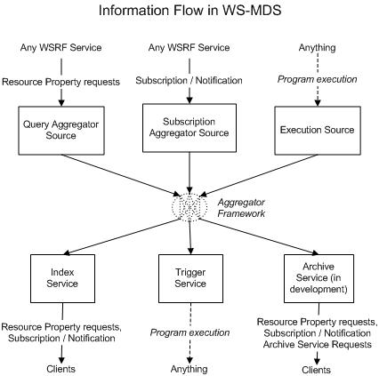

General Information System

Although there is some diversity with the exiting grid information systems with respect to implementation and data models, there is a great deal of commonality between the core functionality and deployment scenarios. At the resource level there is some entity which obtains information from the resource. At the site level there is some entity that aggregates this information. At the Grid level there is some entity that aggregates the information from many sites. The same building block is used at the different levels of the system.
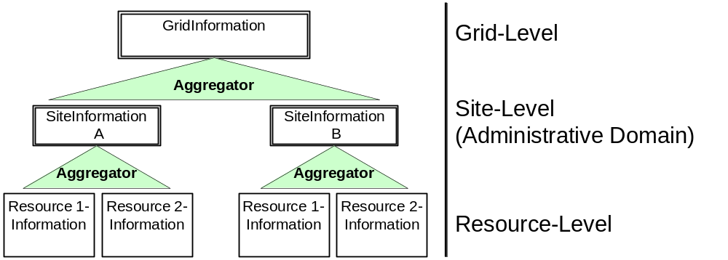Fig. 7.1: Illustration of a grid information system

Resource Level

At the resource level, information has to be gathered about the resource. This is the functionality of the information provider. One of the specific requirements is that the information provider needs to be on the same host as the resource. The content itself should be cached for performance reasons and a throttle control is required so that the resource does not get overloaded. The information service should be lightweight and add negligible load. An interface is required so that the resource information can be queried by a higher level. The functionality could be provided by the service itself or by a parallel service. If the resource can be queried remotely then it is not necessary to have this service on the same host as the resource.

Site Level

At the site level, information has to be gathered about all the resources at the site and cache this information in a database. This usually is achieved by querying the resource level. One of the aims of site level interfaces is to provide a general interface to an arbitrary internal environment. In theory, if a site level interface is used then there is no need for a common resource level interface as an internal custom solution could be used to move the information from the resource to the site level.
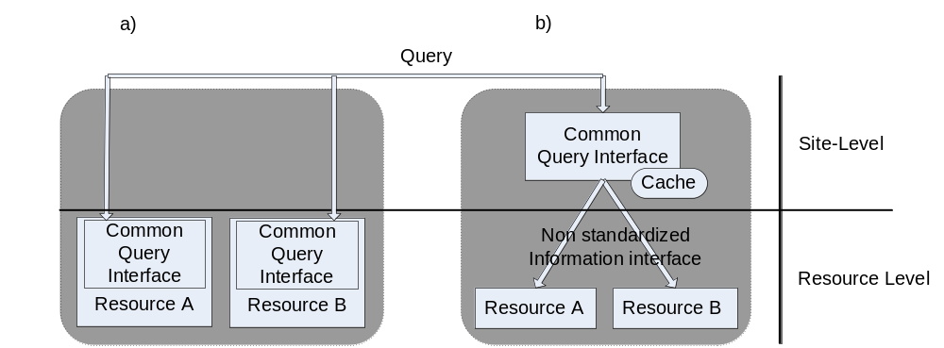

Fig. 8.1: Providing Information at a) resource and b) site level

Grid Level

At the grid level information about all resources needs to be available. The first problem is to find all the information system end points for either the site or the resource level. The very nature of multi-institutional e-Science infrastructures requires that certain administrative procedure is met. This means that the inclusion into the infrastructure depends on the fulfilment of certain requirements inline with policy of the infrastructure. Each infrastructure will therefore maintain a registry of information endpoints. Once the end points have been discovered, the information is extracted and stored in a database for use by other services.

At present all information is cached but grids are now at a scale where it is no longer a viable for all available information. The grid level caches need to be application specific and only cache the information required for a specific activity.

Recommendations for Standards

The greatest need is to standardize the query interface used to extract the information. There are currently three different query mechanisms used, LDAP, OGSA-DAI and WSRF-query.

The registry of endpoints is also required to be standardized. Each infrastructure would maintain its own registry. When two infrastructures decide to interoperate, the location of these registries could be exchanged.

A common information provider framework would be useful so that the developers of the resources, could providing the information provider.

